**Project 1**

**STQD6114 – Unstructured Data Analytics**

**P152419 – Hazim Fitri Bin Ahmad Faudzi**

**Part 1 – Task 3**

**INTRODUCTION**

For this task, we will be exploring lyrics from different genre by analysing text in the lyrics. The chosen lyrics for the analysis are “Blue” by Yung Kai (Genre: Pop), “Rap God” by Eminem (Genre: Hip-Hop), “Lemon Tree” by Fool’s Garden (Genre: Soft Rock), “For the Rest of My Life” by Maher Zain (Genre: Nasheed), and “The Contracts” by Twenty-One Pilots (Genre: Electropop). By looking at the top five terms and their visualization in each word cloud, we can find out the theme of each song.

**FINDINGS**

Across all five songs, the frequency tables and word clouds in the shape of a star can immediately shows each lyric’s theme.

**BLUE – YUNG KAI**

|  |  |
| --- | --- |
| **Term** | **Frequency** |
| Love | 4 |
| Think | 3 |
| Forever | 3 |
| Fall | 2 |
| Imagine | 2 |

Table 1 Frequency Table of Blue – Yung Kai

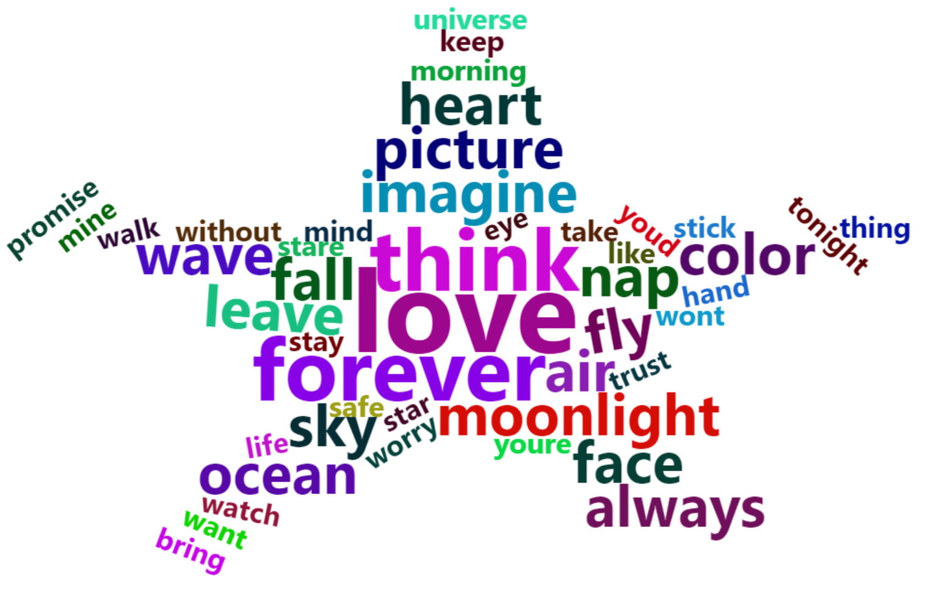

Figure 1 Word Cloud of Blue – Yung Kai

This song focuses on romantic and loyalty. This showed by the word “love” as the top word with four times appearance, followed by “think” and “forever” three times, and “fall” “imagine” appearing two times.

**Rap God – Eminem**

|  |  |
| --- | --- |
| **Term** | **Frequency** |
| Rap | 13 |
| Boy | 12 |
| Lookin | 10 |
| Feel | 8 |
| God | 8 |

Table 2 Frequency Table of Mockingbird - Eminem

Figure 2 Word Cloud of Mockingbird – Eminem

This song is “daddy” and “mama” each appear 10 times, “little” 8 times, and “baby,” “you,” and “feel” at 5. This aligns perfectly with the song’s lullaby-like reassurances, but stemmed forms like “daddys” and “littl” need correction.

* 1. **Lemon Tree – Fool’s Garden**

|  |  |
| --- | --- |
| **Term** | **Frequency** |
| Wonder | 12 |
| Turnin | 12 |
| Blue | 6 |
| Lemon | 6 |
| Tree | 6 |

Table 3 Frequency Table of Lemon Tree – Fool’s Garden

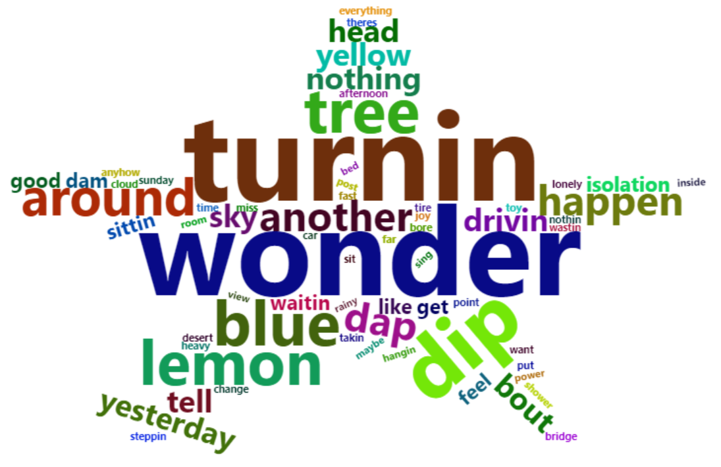

Figure 3 Wordcloud of Lemon Tree – Fool’s Garden

This song reflects curiosity and melody. The word “wonder” and “turnin” both have 12 occurrences, and “blue,” “lemon,” “tree” each with 6 occurences.

* 1. **For the Rest of My Life – Maher Zain**

|  |  |
| --- | --- |
| **Term** | **Frequency** |
| Love | 10 |
| Life | 6 |
| Rest | 6 |
| Allah | 5 |
| Heart | 4 |

Table 4 Frequency Table of For the Rest of My Life – Maher Zain

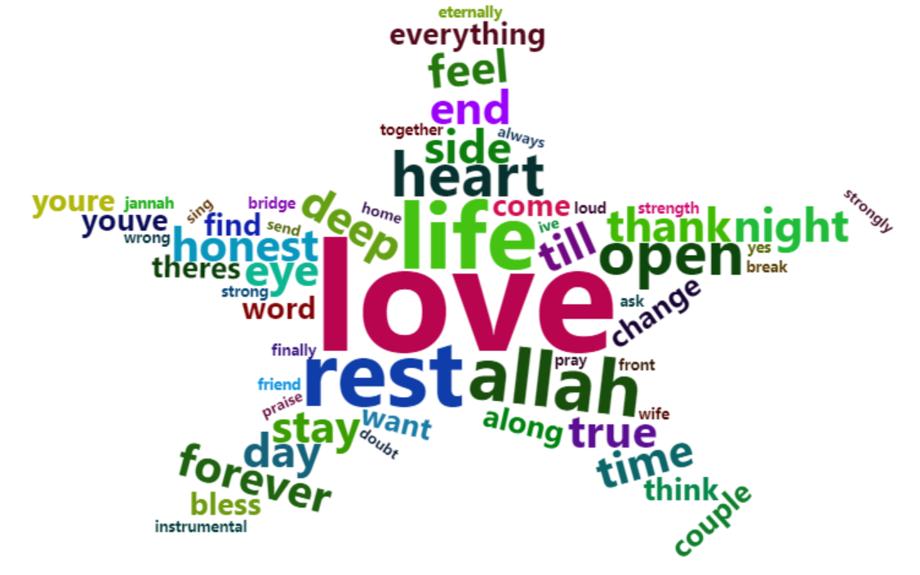

Figure 4 Wordcloud of For the Rest of My Life – Maher Zain

This song from Maher Zain unites devotion and spirituality: “love” appears 10 times, “ill” (from “I’ll”) 16 times, and “rest,” “life” each 6, with “allah” at 5.

* 1. **The Contracts – Twenty-one Pilots**

|  |  |
| --- | --- |
| **Term** | **Frequency** |
| Use | 11 |
| Sleep | 7 |
| Crazy | 6 |
| Howd | 6 |
| Much | 6 |

Table 5 Frequency Table of The Contracts – Twenty-one Pilots

Figure 5 Wordcloud of The Contracts – Twenty-one Pilots

This song from Twenty-one Pilots highlights obligation and routine. This shown by the word “use” that appear 11, “sleep” 1 times, and “crazy”, “howd”, and “much” appear 9 times.

**CONCLUSION**

When properly preprocesses, term-frequency and word-cloud techniques reveal each song’s emotional and concept. It can be said that “Blue” has romantic concept. introspective longing in “Lemon Tree,” religious in “For the Rest of My Life,” and existential bind in “The Contracts.” Addressing stemming artifacts, pruning non-thematic tokens, and extracting multi-word phrases transforms a raw frequency dump into a nuanced, reader-friendly portrait of lyrical intent.